# Dunamis AI Consult Website Project Copies

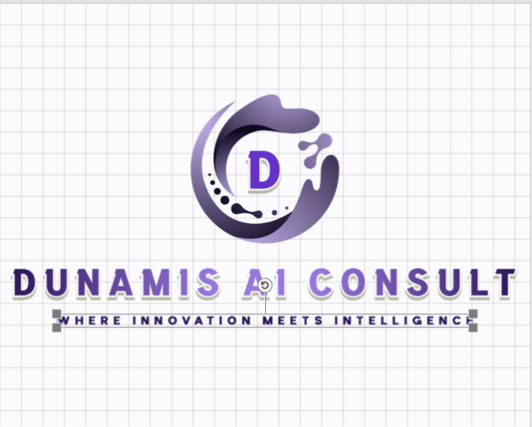

Business Logo

## HOME PAGE

## ABOUT PAGE

**Slogan:** Where innovation meets intelligence. Not Just a Vision, But a Reality!!

Dunamis AI Consult Your Catalyst for Change! Not Just a Vision, But a Reality!!

**About Us**

Welcome to **Dunamis AI Consult**, where innovation meets intelligence! We're a cutting-edge technology company that's pushing the boundaries of Artificial Intelligence (AI), Machine Learning (ML), and software development. Our team of experts is passionate about harnessing the power of technology to drive business success and transform industries.

**Mission Statement**

Our mission is to empower businesses and organizations to achieve their goals through innovative AI-powered solutions, exceptional software development, and unparalleled customer service. We strive to deliver tailored solutions that meet the unique needs of our clients, fostering long-term partnerships and driving mutual success.

**Vision Statement**

Our vision is to be a global leader in AI-driven innovation, revolutionizing the way businesses operate, interact, and make decisions. We envision a future where technology seamlessly integrates with human intelligence, unlocking unprecedented potential for growth, efficiency, and progress.

**What We Do:**

At **Dunamis AI Consult**, we specialize in:

* **Artificial Intelligence (AI) and Machine Learning (ML) solutions**
* **Web Development:** crafting responsive, user-friendly, and engaging websites
* **Mobile Application Development:** building innovative, intuitive, and secure mobile apps
* **Web Application Development:** designing and developing robust, scalable, and feature-rich web applications
* **Chatbot and Virtual Assistant Development:** we design, build and deploy conversational interfaces that enables humans to interact with computers, software or machines using natural language.

**Why Choose Us?**

* **Expertise:** Our team of experts has extensive experience in AI, ML, and software development.
* **Innovation:** We stay at the forefront of technological advancements, ensuring our solutions are cutting-edge and effective.
* **Customer-centric:** We prioritize customer satisfaction, delivering tailored solutions that meet unique needs and goals.
* **Agility:** We're adaptable and responsive, ensuring rapid deployment and seamless integration.

**Get in Touch:**

Ready to unlock the power of AI and innovation for your business? Contact us today to explore how we can help you achieve your goals!

**[Insert Hyperlink to the Contact Us Page]**

**“Not Just a Vision, But a Reality!!”**

## CONTACT US PAGE

**Physical Address:**

1301, South Bowen Road

Suite 450

Arlington, TX 76013

United States

**Email:** [dunamis_ai_consult@ai.com](mailto:dunamis_ai_consult@ai.com)

**Contact Number:** 089 675 4312

**Operational Hours:**

Mondays - Fridays: 8 am – 5 pm

Saturdays: 9 am – 1 pm

Embed a Google Map

**Home Page:**

1. **Hero Section:** Showcase the company's expertise in AI, Machine Learning, and software development.

2. **What We Do:** Briefly describe the company's services, including AI, Machine Learning, Web Development, Mobile Application Development, and Web Application Development.

3. **Why Choose Us:** Highlight the company's unique value proposition, including expertise, innovation, and customer satisfaction.

4. **Call-to-Action:** Encourage visitors to explore the website further or contact the company.

5. **Featured Projects:** Showcase 2-3 recent projects that demonstrate the company's expertise.

**About Page:**

1. **Company Overview:** Provide a detailed overview of the company, including its mission, vision, and values.

2. **Team Members:** Introduce the company's team members, including their photos, names, and brief descriptions.

3. **Testimonials:** Showcase testimonials from satisfied clients, highlighting the company's expertise and customer satisfaction.

4. **Awards and Recognition:** List any notable awards or recognition the company has received.

Product and Services Page:

1. **AI Solutions:** Describe the company's AI solutions, including Machine Learning, Natural Language Processing, and Computer Vision.

2. **Web Development:** Outline the company's web development services, including custom web development, e-commerce solutions, and web application development.

3. **Mobile Application Development:** Describe the company's mobile application development services, including iOS, Android, and cross-platform development.

4. **Web Application Development:** Outline the company's web application development services, including custom web application development and enterprise software development.

**Gallery:**

1. **Project Showcase:** Showcase the company's projects, including images, descriptions, and technologies used.

2. **Team Photos:** Share photos of the company's team members, highlighting the company culture.

3. **Events and Conferences:** Showcase the company's participation in events and conferences, highlighting its thought leadership.

**Contact Us:**

1. **Contact Form:** Provide a contact form for visitors to get in touch with the company.

2. **Address and Phone Number:** List the company's physical address and phone number.

3. **Email Address:** Provide a general email address for inquiries.

4. **Social Media Links:** Include links to the company's social media profiles.

5. **Map:** Embed a map to help visitors locate the company's office.